Streamlining IT Procurement: Automating Standard Laptop Orders with Flow Designer
Phase 7 – Project Documentation

1. Project Title
Streamlining IT Procurement: Automating Standard Laptop Orders with Flow Designer
2. Platform and Module
Platform: ServiceNow
Module: Flow Designer
Service Catalog: Hardware → Standard Laptop
3. Flow Configuration
Name: Standard laptop task
Application: Global
Run user: System user
Trigger: Service Catalog
Action: Create Catalog Task
4. Catalog Task Configuration
Request item: Requested Item Record
Table: Catalog Task
Short description: Laptop need to Configured
Description: Laptop need to Configured
Assignment group: Hardware
Approval: Approved
5. Flow Assignment
The Flow is assigned to the Standard Laptop service catalog item through Maintain Items → Standard Laptop → Process engine.
6. Request Verification
A Standard Laptop request is placed through Service Catalog → Hardware → Standard Laptop. The request number and Approvers section are reviewed, the request is approved, and the Requested Item is opened to review Catalog Tasks.
7. Documentation Evidence

Flow properties
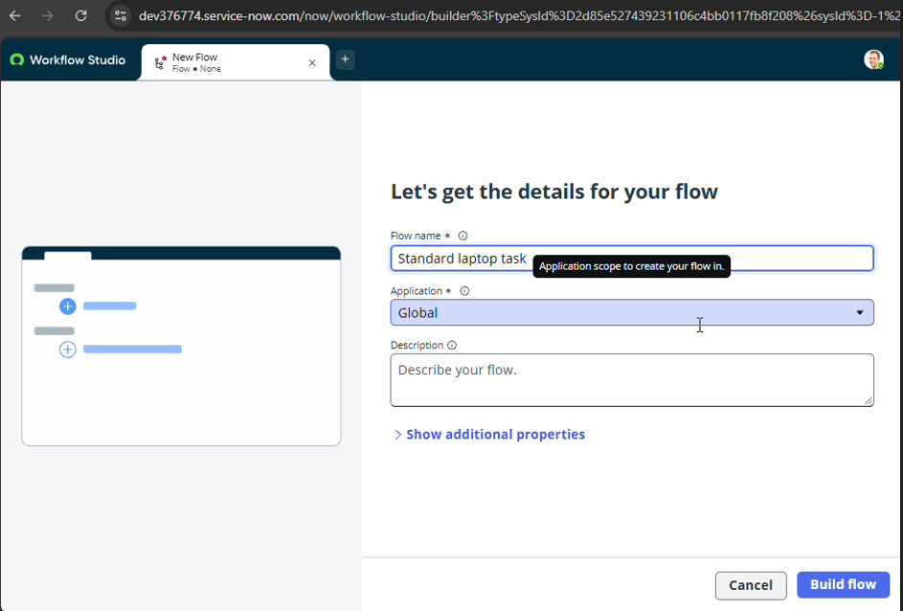
Service Catalog trigger
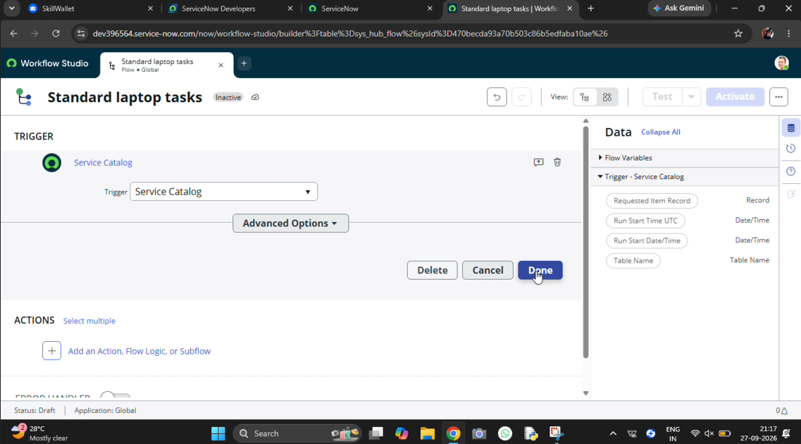

Create Catalog Task action
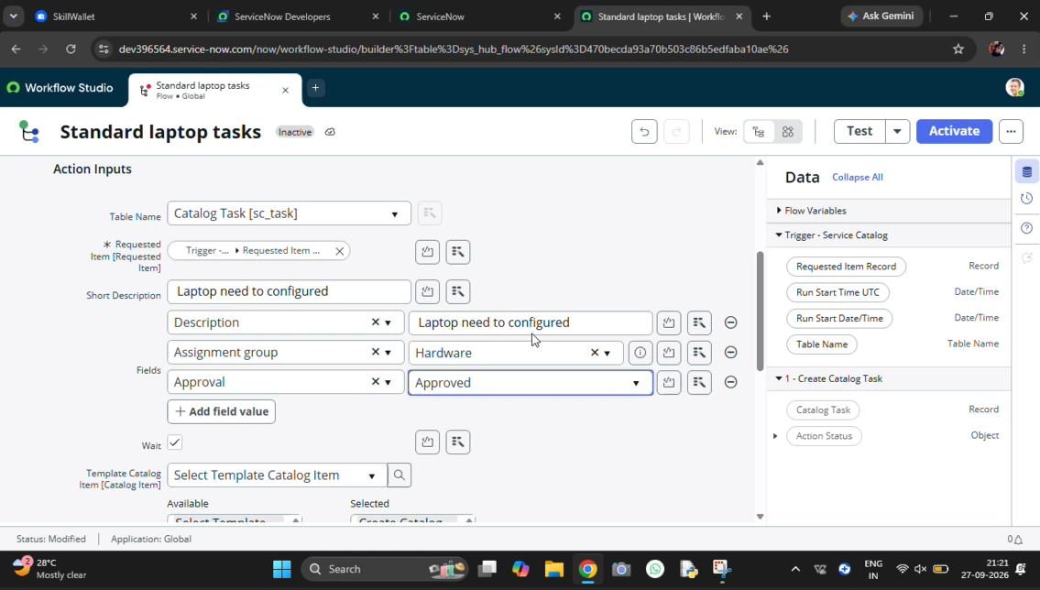
Maintain Items Process engine assignment
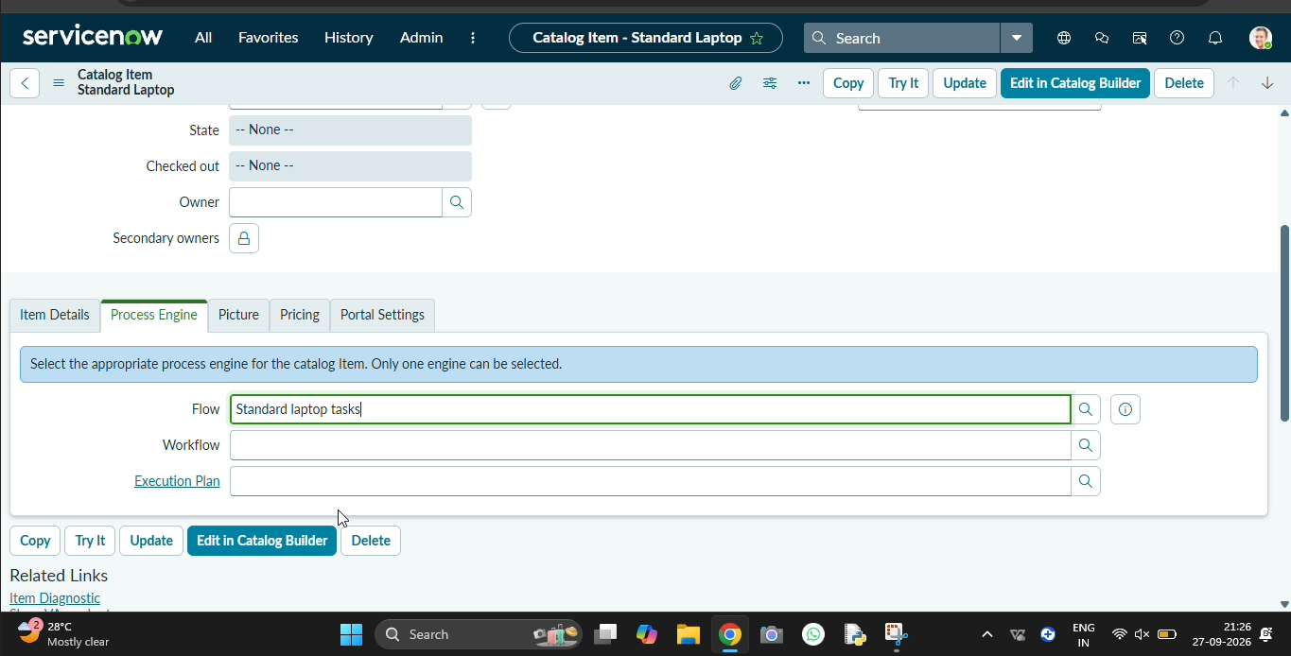
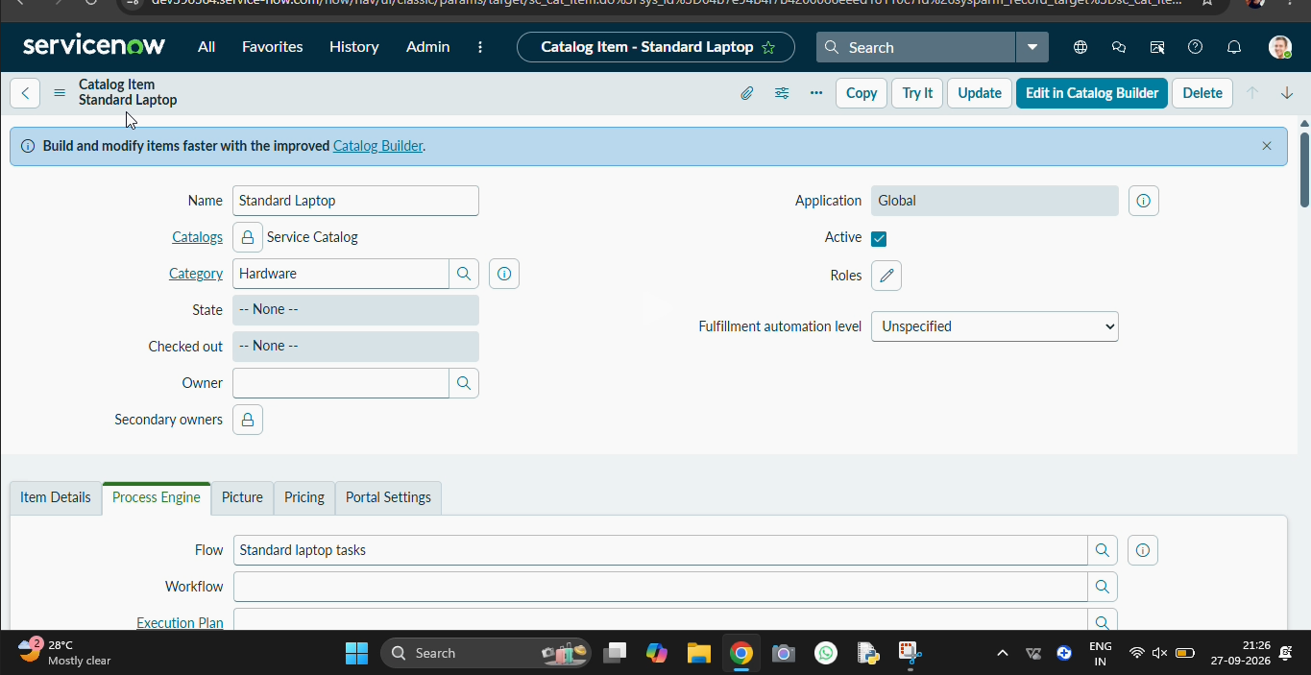

request approval
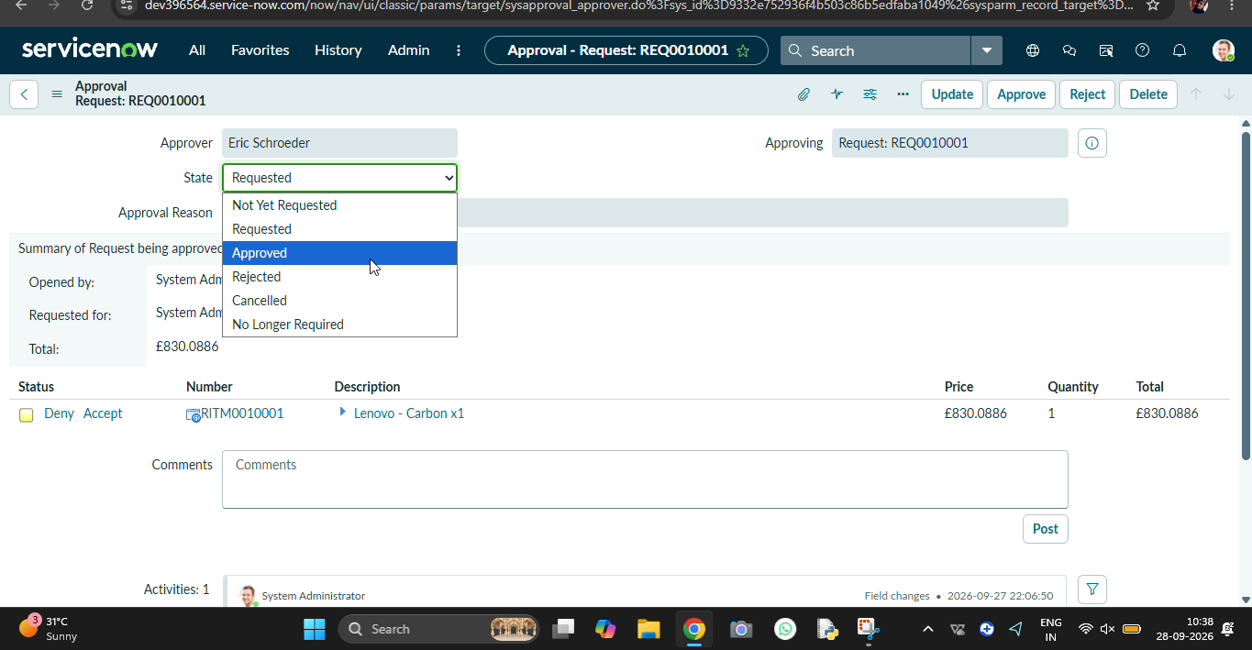

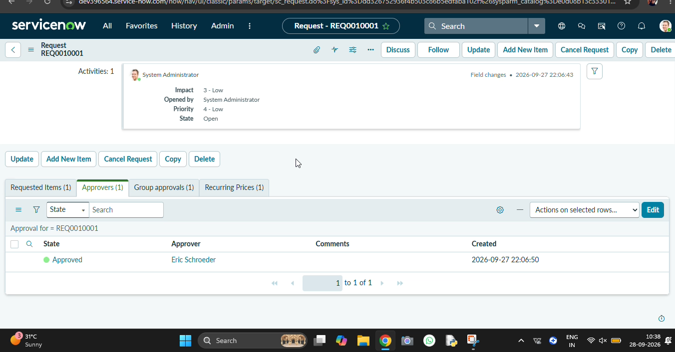

Requested Item
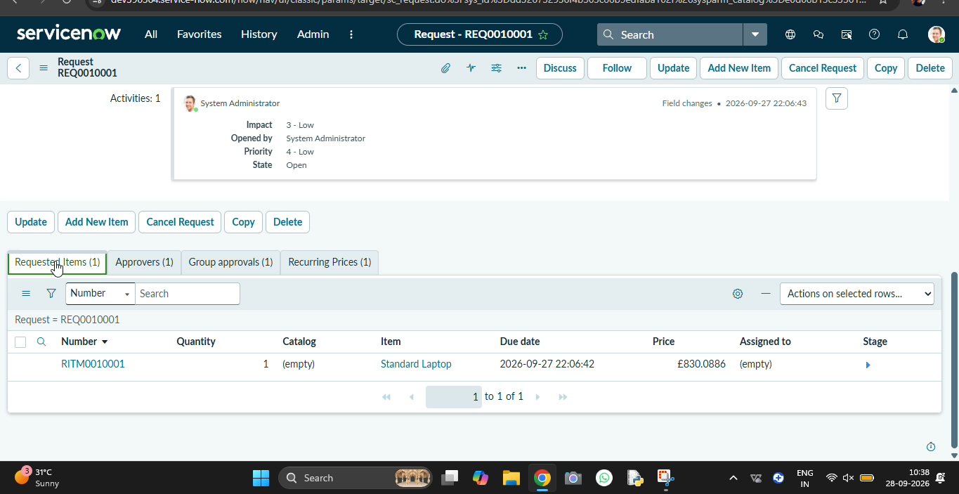

Catalog Task record
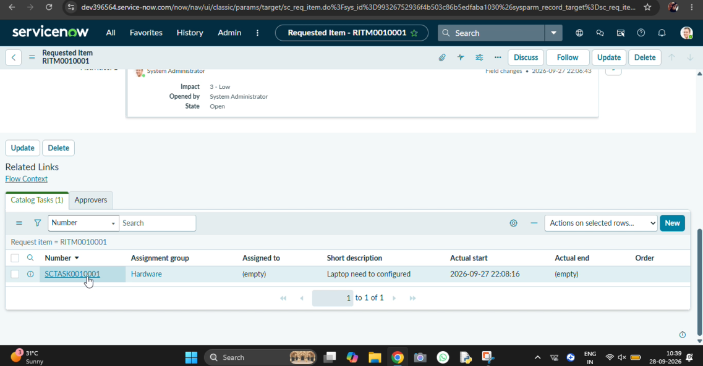

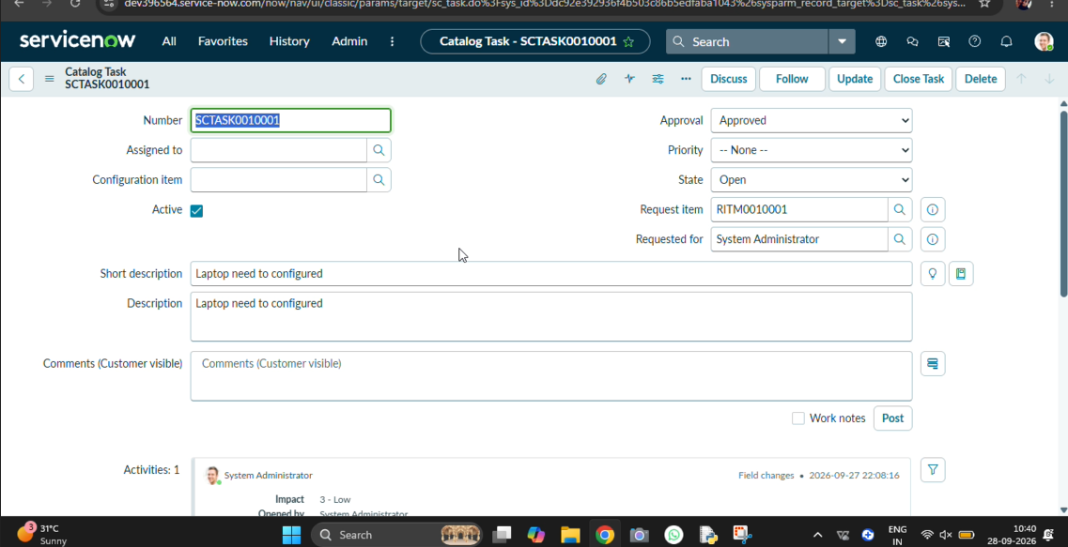

Project Status: Completed

